Attendance System

**Designed and developed by Sachin Nagnath Isamantri PRN :- 2021420070**

##### Third Year Bachelor of Science

**(Computer Science)**

##### Under the esteemed Guidance of Prof. Neehit Tiwari (Assistant Professor)

**Department of Computer Science**

##### VPM’s B. N. Bandodkar College of Science (Autonomous)

**THANE(W)-400601**

**Maharashtra YEAR -2023-24**

# CERTIFICATE

This is to certify that **Mr. Sachin Nagnath Isamantri** has successfully developed **Attendance system** as per our project requirements. His dedication, expertise, and commitment to this project have been commendable. The Application he has created encompasses essential features such as signup and login page , Admin page and Attendance System.

**Mr**. **Sachin Nagnath Isamantri** has demonstrated a deep understanding of web development technologies, including HTML, CSS, JavaScript , PHP and MySQL. His meticulous attention to detail, problem- solving skills, and commitment to delivering a high-quality product have been instrumental in the success of this project.

We extend our sincere appreciation to **Mr. Sachin Nagnath Isamantri** for his hard work and dedication in developing this web application, which has significantly improved our attendance management process and students experience.

**(Client Signatures)**

**Abstract**

The “Attendance System ” project is a remarkable creation developed specifically for a tutorial class. It showcases a skillful fusion of PHP for the backend, MySQL for data storage, and a frontend crafted with HTML, CSS, and JavaScript. This project represents a practical demonstration of modern technology’s application to the realm of attendance management.

MySQL has been chosen as the database system, offering scalability and flexibility for storing attendance records. Its nature simplifies data retrieval and manipulation, which is particularly advantageous when handling substantial amounts of attendance data.

The frontend, created using HTML, CSS, and JavaScript, provides an intuitive and responsive user interface. This web-based interface empowers attendees and administrators to seamlessly interact with the system. JavaScript enhances the system’s interactivity, allowing for real-time updates and a smooth user experience.

Developed explicitly for a tutorial class, this project not only simplifies attendance management but also demonstrates the application of technology to practical challenges. It underscores how Python, MySQL, PHP , HTML, CSS, and JavaScript can be harmoniously integrated to create a robust, efficient, and user-friendly solution for -based attendance management. Your project serves as an inspiration for students and showcases the capabilities of modern technology.

## Acknowledgment

I would like to express my heartfelt gratitude to the B. N. Bandodakar College of Science for providing me with the opportunity to pursue this project. The college’s nurturing environment and resources have been instrumental in the successful completion of the “Attendance System .”

I extend my sincere appreciation to my project guide, Mr. Neehit Tiwari, for his invaluable guidance, unwavering support, and expertise throughout the project’s development. His mentorship has been pivotal in shaping the project and enhancing my understanding of the subject matter.

I would also like to acknowledge the faculty and staff at B. N. Bandodakar College of Science for their continuous encouragement and assistance during this project.

Lastly, I thank my family and friends for their encouragement and patience during the project’s journey.

The successful completion of this project would not have been possible without the collective support and guidance I have received from these individuals and institution.

## Declaration

I, Sachin Nagnath Isamanti, a student of B. N. Bandodkar College of Science, hereby declare that the project titled “Attendance System ” presented in fulfillment of the requirements for Bachelors of Science (Computer Science) is entirely my original work. This project was carried out under the guidance of Mr. Neehit Tiwari, to whom I am deeply grateful for

His invaluable assistance and mentorship throughout its development.

I affirm that I have duly acknowledged all sources of information and assistance received during the project’s completion and have appropriately cited and referenced any external material used in accordance with academic guidelines. This project has not been submitted elsewhere for academic evaluation, and I understand the implications of academic dishonesty and plagiarism.

I attest that the content of this project is entirely my own, except where otherwise acknowledged. I hereby submit this project for evaluation with full confidence in its authenticity and quality.

Sachin Nagnath Isamanti

B. N. Bandodkar College of Science

|  |  |  |  |
| --- | --- | --- | --- |
| **Sr. No.** |  | **Table of Contents** | **Page No**. |
| **1.** |  | **Introduction** | 8-16 |
|  |  | Background |  |
|  |  | Feasibility Study |  |
|  |  | Objectives |  |
|  |  | Scope |  |
|  |  | Purpose |  |
|  |  | Advantages |  |
|  |  | Applicability |  |
|  |  | Achievements |  |
| **2.** |  | **Survey of Technologies** | 17-19 |
| **3.** |  | **Requirement Analysis** | 20-26 |
|  |  | Problem Definition |  |
|  |  | Requirement Specification |  |
|  |  | Planning and Scheduling |  |
|  |  | Software and Hardware Requirement |  |
|  |  | Event Table |  |
| **4.** |  | **System Design** | 27-45 |
|  |  | Basic Module |  |
|  |  | Data Design |  |
|  |  | Data Integrity and Constraints |  |
|  |  | Logic Diagram |  |
|  |  | Test Case Design |  |
| **5.** |  | **Implementation and Testing** | **39-46** |
|  |  | Testing Approach |  |
|  |  | Coding Details and Code Efficiency |  |
| **6.** |  | **Results** | 47-49 |
| **7.** |  | **Conclusion and Future Work** | 50-53 |
|  |  | Future Enhancement |  |
|  |  | Conclusion |  |
|  |  | System Maintenance |  |
| **8.** |  | **References** | 53 |

**Introduction**

##### Background

##### The “Attendance System” project has been designed to meet the contemporary needs of tutorial classes where traditional attendance tracking methods prove cumbersome and prone to errors. By harnessing technology, this project offers an efficient and accurate solution. Developed within the framework of modern programming languages, including PHP for the backend and HTML, CSS, and JavaScript for the frontend, the system aims to streamline attendance management in tutorial class settings. Its inception is a response to the demand for simplified, error-free attendance tracking in educational environments.

* 1. **Feasibility Study**
* Technical Feasibility :-

Technical feasibility refers to the assessment of whether a proposed project or system can be developed and implemented using existing technology, resources, and skills. In the context of an attendance system based on using Python, it involves evaluating whether such a system can be practically built and integrated into the existing infrastructure . Technical Feasibility Factors are as follows :

1. Software Requirements

Web Server :- Apache

DBMS :- MySQL

Programming language:- PHP

Frontend :- HTML , CSS , JAVASCRIPT

1. Hardware Requirements(minimum)

As this is online system no physical components required

Just some of the specifications of Computer being use should be :-

RAM :- 4 GB

SSD :- 512 GB

PROCESSSOR :- Intel icore i5

1. Data Storage and Database Management

The system needs to store the facial data (images) of students in a database for comparison during attendance tracking. PHP provides multiple database management systems like MySQL , SQLite , etc

* Economic Feasibility

Economical feasibility for attendance system involves evaluating the financial viability of implementing and maintaining the system. It assesses whether the benefits derived from the system justify the costs incurred. Here are the key aspects to consider for the economical feasibility

A) Development Costs

The required resources like VS code , XAMPP etc. for this project are absolutely free online . However downloading this resources from official sources and setup requires proper knowledge and data charges .

B) Component Costs

We need a laptop/Computer for this project. No extra cost needed.

1. Operational Costs

Considering ongoing costs, such as maintenance, software updates, technical support, and any required data storage or cloud services. Which may cause increase in money charged by developer from the client.

###### Operational feasibility

###### Operational feasibility refers to the assessment of whether a proposed system, such as a attendance system, can be effectively and efficiently operated within the existing organizational or operational environment. It focuses on evaluating whether the system can be smoothly integrated into the daily operations and whether the users can adapt to and use the system without significant disruptions. Operational Feasibility Factors are as follows;

###### A] User Acceptance

###### One of the primary considerations is whether the user will readily accept the new attendance system. Resistance to change or concerns about privacy and data security could potentially hinder user acceptance . As Developer we need insure the users data is completely safe

###### B] User Training and Familiarization

###### Assessing the ease of use of the system is crucial. If the system requires complex interactions or is not intuitive, it may necessitate extensive training for the users, which could impact operational feasibility. Thus , this system is very much user friendly. Everyone can learn using this system very easily.

###### C] Integration with Existing Processes

###### The existing system was quite easy for those who aren’t familiar with technology .This new system is enhanced with technology . Therefore, using this new system requires proper training for both teachers and students of the Anam Cara Tutorials.

1. Scheduling and Timeline

Scheduling feasibility refers to the assessment of whether a proposed project, such as implementing a attendance system, can be completed within a reasonable time frame. It involves evaluating the availability of resources, time constraints, and potential conflicts with other ongoing projects or commitments.

Considering all the aspects for scheduling and timeline of this project like developing the project, testing , deployment , user training , maintenance , etc. And concurrently I also have to handle my studies

Simultaneously developing this project . I will try to handover this system(fully operational) to the client in roughly 2 months .

##### Objectives

* **Automation of Attendance:** The primary objective of the “Attendance System” project is to automate the attendance tracking process in tutorial classes, eliminating the need for manual record-keeping.
* **Accuracy and Reliability:** Ensure accurate and reliable attendance records by leveraging technology, reducing the potential for errors or proxy attendance.
* **Real-time Tracking:** Implement real-time attendance tracking to provide instant visibility of attendee presence, facilitating prompt intervention when needed.
* **User-Friendly Interface:** Create an intuitive and user-friendly web interface for both administrators and attendees, ensuring ease of use and accessibility.
* **Security Enhancement:** Enhance security by utilizing for user authentication, preventing unauthorized attendance marking.
* **Data Management:** Efficiently store attendance data in MySQL, allowing for easy retrieval, reporting, and analysis.
* **Adaptability:** Ensure the system’s adaptability to varying environmental conditions and lighting for reliable performance in different settings.
* **Educational Support:** Serve as a practical learning tool for students to understand the integration of modern technology into everyday tasks.
* **Tutorial Class Optimization:** Optimize the attendance management process specifically for tutorial classes, addressing the unique needs and challenges of this educational setting.
* **Practical Demonstration:** Showcase the application of Python, MySQL, and web technologies in solving real-world attendance tracking problems within the tutorial class context.

##### Purpose

The purpose of the “Attendance System” project is to revolutionize and simplify attendance tracking in tutorial classes by harnessing the capabilities of technology. This project aims to address the following key purposes:

* **Efficiency:** To enhance the efficiency of attendance management by automating the process, reducing the administrative burden on instructors, and saving valuable class time.
* **Accuracy:** To improve the accuracy of attendance records, minimizing the likelihood of errors associated with manual methods and preventing proxy attendance.
* **Security:** To enhance the security of attendance tracking by implementing for user authentication, ensuring that only authorized individuals can mark their attendance.
* **Accessibility:** To provide a user-friendly web interface that makes attendance tracking accessible and intuitive for both administrators and attendees, promoting ease of use.
* **Real-time Monitoring:** To enable real-time monitoring of attendance, allowing instructors to promptly address attendance-related issues as they arise.
* **Educational Demonstration:** To serve as an educational tool for students, showcasing the practical application of modern technology in solving real-world challenges.
* **Adaptability**: To create a system that can adapt to different environmental conditions and lighting, ensuring reliable performance in various tutorial class settings.

##### Scope

The scope of the “Attendance System ” project encompasses the following areas:

###### Development Phase

This phase involves the design and implementation of the algorithm using Python, the integration of MySQL for secure data storage, and the creation of a user- friendly web-based frontend using HTML, CSS, and JavaScript. Real-time attendance tracking functionality and secure user authentication through will be key features.

###### Implementation Phase

During this phase, the system will be deployed in tutorial class settings for practical use. Instructors and attendees will receive training on system usage. Continuous monitoring and user feedback will inform improvements.

###### Potential Expansion

Consideration will be given to the system’s scalability for larger class sizes or multiple tutorial classes. Potential additional features, such as attendance analytics and reporting, will be explored. The adaptation of the system for use in other educational or corporate settings may also be examined.

###### Documentation

Comprehensive documentation will cover system architecture, components, and usage instructions. A user manual will be created for reference.

###### Testing and Evaluation

Rigorous testing will ensure accuracy, reliability, and security. Ongoing evaluation will identify and address potential issues or limitations.

###### Educational Value

The project will serve as an educational resource, demonstrating the practical application of technology in attendance management. Insights and findings will be shared within the tutorial class community and potentially with a broader audience interested in similar solutions.

##### Achievements

After doing this project I got to know how a project is managed and completed successfully to meet its goals. I also got a lot of new information about the software I used to develop this project. Client is presently using the project and is very satisfied. Objectives stated of projects are fulfilling the client needs. Client manage all data on this software in less amount of time and money consumption.

* 1. Advantages
     1. Efficiency:-

The system automates attendance tracking, saving valuable class time and reducing administrative workload by eliminating the need for manual record-keeping.

* + 1. Accuracy:-

technology ensures precise attendance records, minimizing the chances of errors associated with

traditional methods and deterring proxy attendance.

* + 1. Security:-

The system enhances security through - based user authentication, preventing unauthorized access and attendance marking.

* + 1. Real-time Monitoring:-

Real-time attendance tracking provides immediate visibility of attendee presence, enabling prompt intervention when necessary.

* + 1. User-Friendly Interface:-

The intuitive web interface is accessible to both administrators and attendees, promoting ease of use and accessibility.

* + 1. Data Management:-

Attendance data is efficiently stored , allowing for easy retrieval, reporting, and analysis.

* + 1. Adaptability:-

The system adapts to varying environmental conditions and lighting, ensuring reliable performance in diverse tutorial class settings

## SURVEY OF TECHNOLOGY

**TOOLS**:-

### The tools that we are using for this software are as follows:

* Microsoft Visual Studio Code

##### VISUAL STUDIO CODE

Visual Studio Code (VS Code) is a lightweight yet powerful source code editor developed by Microsoft. It has gained immense popularity among developers for its versatility and extensive features. VS Code supports various programming languages and offers intelligent code completion, syntax highlighting, and debugging capabilities. Its real-time collaboration features and a vast library of extensions further enhance its functionality. Users can customize their workspace with themes, key bindings, and extensions, tailoring it to their preferences. VS Code’s Git integration simplifies version control, and its built-in terminal streamlines development workflows. Its cross- platform compatibility ensures a consistent experience on Windows, macOS, and Linux, making it a top choice for developers across the world.

**TECHNOLOGY**:- Technologies that we have used in our project are as follows:

* + HTML
  + CSS
  + JAVASCRIPT
  + MYSQL
  + PHP

1. **HTML (Hypertext Markup Language) :-** HTML is the standard markup language used to create and structure content on the World Wide Web. It provides a set of tags and elements to define the structure and layout of web pages, including headings, paragraphs, links, images, and more.
2. **CSS (Cascading Style Sheets):-**CSS is a stylesheet language that complements HTML by controlling the presentation and layout of web pages. It allows web developers to define styles, such as fonts, colors, spacing, and positioning, to ensure a consistent and visually appealing design.
3. **JavaScript:-**JavaScript is a versatile and widely used programming language for web development. It enables interactivity on web pages, making them responsive to user actions. JavaScript can manipulate HTML and CSS, handle user input, and interact with web servers to create dynamic web applicatio
4. **MySQL**:-MySQL is an open-source relational database management system (RDBMS) that has gained widespread popularity for its reliability and performance. It allows users to store and manage structured data efficiently, making it an excellent choice for applications that require data storage and retrieval. MySQL is known for its scalability, security features, and support for SQL, making it a preferred choice for web developers, businesses, and organizations seeking a robust database solution.
5. **PHP**: - PHP (Hypertext Preprocessor) is a widely-used open-source scripting language that is especially well-suited for web development. It excels at generating dynamic web content, handling forms, interacting with databases, and much more. PHP is known for its simplicity and versatility, making it a top choice for creating dynamic websites and web applications. With a large and active community, it continues to evolve and remains a powerful tool in the world of server-side scripting for web development.

## Requirement Analysis

###### Problem Definition

In this phase, the project team defines the problem or challenge that the “Attendance System ” project aims to address. This includes identifying the shortcomings of existing manual attendance tracking methods in tutorial classes, such as time-consuming processes and potential errors, and recognizing the need for a more efficient and accurate solution.

###### Requirement Specifications

Once the problem is well-defined, the team proceeds to outline the specific requirements that the system must fulfill. This involves determining functional and non- functional requirements, such as the need for real-time attendance tracking, secure user authentication, adaptability to different environments, and user-friendly interfaces. Requirement specifications serve as the foundation for the system’s design and development, guiding its features and functionalities

* **Planning and scheduling** **Lifecycle of Project:-**

SDLC stands for Software Development Life Cycle.

It is a systematic approach used in software engineering to guide the development and maintenance of software products. The specific activities and processes within each phase of the SDLC may vary depending on the development methodology used. The fundamental stages generally include : Requirements Gathering , System Design ,

Implementation , Coding , Testing , Deployment and Maintenance.

##### Incremental Model

The Incremental Model is a software development approach that combines the elements of the linear, sequential Waterfall Model with the iterative nature of prototyping. It involves breaking down the software development process into smaller, manageable parts or increments. Each increment represents a portion of the system’s functionality and is developed separately in a sequential manner.

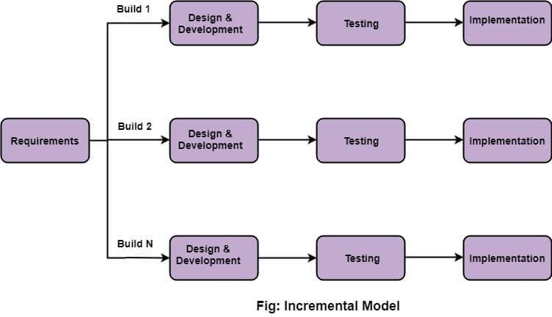

* 1. Requirement analysis

In the first phase of the incremental model, the product analysis expertise identifies the requirements. And the system functional requirements are understood by the requirement analysis team.

* 1. Design & Development

In this phase of the Incremental model of SDLC, the design of the system functionality and the development method are finished with success.

* 1. Testing

In the incremental model, the testing phase checks the performance of each existing function as well as additional functionality. In the testing phase, the various methods are used to test the behavior of each task.

* 1. Implementation

Implementation phase enables the coding phase of the development system. It involves the final coding that design in the designing and development phase and tests the functionality in the testing phase. After completion of this phase, the number of the product working is enhanced and upgraded up to the final system product .

Why to use Incremental Model ?

Using the Incremental Model for the “Attendance

System ” project can be advantageous for several reasons . Here are the key reasons why the Incremental Model is well-suited for this project:

1. Progressive Development :- The Incremental Model allows you to start with the core functionality, which is -based attendance. This enables you to have a working system with essential features early in the development process.
2. Manageable Scope:- Breaking the project into smaller increments makes it more manageable. You can focus on developing specific functionalities in each increment, allowing you to handle the project step-by-step rather than tackling the entire system all at once.
3. Mitigation of Risks:- As a beginner, it can be challenging to foresee all potential risks in the initial stages. With the Incremental Model, you can address and mitigate risks early in the development process, reducing the impact of any issues that may arise.
4. Faster Delivery of Core Features:- The Incremental Model allows you to deliver the core functionality, -based attendance, in the initial increments. This can provide value to the client (Ms. Smita Waikar) sooner and allow them to start using the system

earlier.

1. Adaptability to Evolving Requirements:- technology and attendance systems might have evolving requirements or new research findings. The Incremental Model’s iterative nature allows you to adapt to changes more easily during the development process.

* 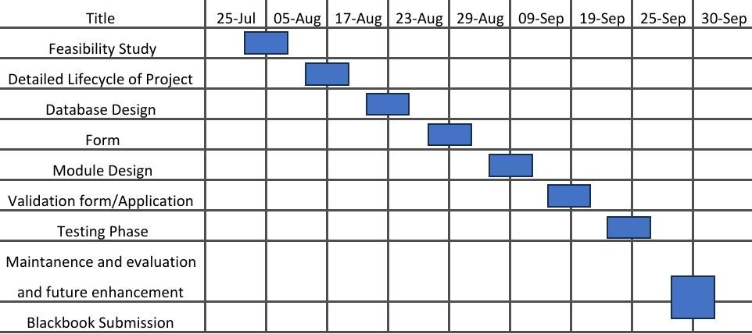**GANTT Chart** :- A Gantt chart is a visual project management tool used to plan, schedule, and track tasks and activities within a project. It displays project tasks as horizontal bars on a timeline, with each bar representing a specific task, its start and end dates, and its duration. Gantt charts provide a clear and organized way to visualize project timelines, task dependencies, and progress, making them a valuable resource for project managers and teams to manage and communicate project details effectively.

##### Software and Hardware Requirement:-

* + **Software Requirements:-**

##### Operating System : Windows 10 and higher

* + **Front-end : HTML CSS,JAVASCRIPT**

##### Back-end: MYSQL,PHP

* **Hardware Requirements: -**

##### Memory : Minimum 4 GB RAM

* + **Hard disk : Minimum 512 GB**
  + **Processor : Minimum 64-bit processor**

## Event Table

|  |  |  |  |  |
| --- | --- | --- | --- | --- |
| Event | Source | Description | Trigger | Destination |
| Admin Registration | Admin | Admin register himself into the system | Registered Successfully | Admin |
| Admin Login | Admin | Admin will login into the system | Logged in successfully | Admin |
| Adding Student’s data | Admin | Admin stores the data of students into the system | Student’s Data Added to the system | Admin |
| Update Student’s data | Admin | Admin updates existing student’s data | Student’s data updated | Admin |
| Delete Student’s data | Admin | Admin deletes student’s data | Student’s data deleted | Admin |
| Giving Attendance | Student | Student marks attendance by showing his face to camera | Attendance Marked successfully | Admin |
| Taking Attendance | Admin/Teacher | Admin/Teacher will take attendance of student | Attendance marked successfully | Admin |

#### System Design

**BASIC MODULE :-**

Basic module within the system design for an Attendance System might include:

Module Name: User Authentication Purpose:

* To authenticate and authorize users to access the system,

distinguishing between students and instructors.

Components:

1. Registration:
   * Allows users to create an account by providing necessary information.
   * Captures and stores user details securely.
2. Login:
   * Enables users to log in with their credentials (username and password).
   * Verifies user identity and grants access to the system.

Interactions:

* This module interacts with the database to store user data (username and password) securely.
* It interfaces with the frontend for user registration and login.
* It integrates with other modules to ensure authenticated users can access their respective dashboards and features.

Security Considerations:

* Encryption of user passwords.
* Protection against brute force attacks.
* Secure session management to prevent unauthorized access.

Error Handling:

* Handling invalid login attempts.
* Guiding users through the registration and password reset processes.

This module forms the basis for user management and access control in the attendance system. It ensures that only authorized users can use the system and access their respective features.

Module Name: Admin Panel Purpose:

- To provide administrators with tools to manage,

monitor, and the attendance system.

Components:

1. User Management:
   * Admins can add, edit, or remove user accounts (students and instructors).
   * Can assign roles and permissions to users.
2. Class Management:
   * Admins can create, edit, and delete classes or courses.
   * Assign instructors to classes and manage class schedules.
3. Attendance Records:
   * View and download attendance records for various classes.
   * Generate reports and statistics on attendance.

Interactions:

* The admin panel interacts with the database to manage user accounts, classes, and attendance records.
* It communicates with the backend to update system configurations.
* It may have its dedicated web interface or can be integrated with the main web application.

Security Considerations:

* Access control and authentication for admin users.
* Logging and auditing of admin actions.
* Ensuring sensitive configurations are accessible only to authorized admins.

#### Database Design:-

Database design is the process of structuring and organizing data to efficiently store, retrieve, and manage information. It involves defining tables, fields, relationships, and constraints to ensure data accuracy and integrity.

First, identify the data requirements and understand the business needs. Then, create an Entity-Relationship Diagram (ERD) to visualize data entities and their relationships. Choose an appropriate database management system (DBMS) like MySQL, PostgreSQL, or NoSQL options like MongoDB based on your project’s needs.

Design the database schema, specifying tables and their attributes,

data types, and primary/foreign keys. Normalize the data to eliminate redundancy and improve efficiency. Establish constraints and rules to maintain data integrity, such as unique constraints, check constraints, and foreign key constraints.

Consider indexing to enhance query performance and optimize the database for the expected workload. Implement security measures to protect sensitive data, and plan for data backup and recovery.

Finally, test the database design thoroughly, making adjustments as needed. A well-designed database is essential for data reliability, scalability, and efficient data processing.

#### Data Integrity:-

Data integrity and constraints are essential aspects of a well- designed database system, ensuring the accuracy and reliability of stored data. In the context of your Attendance System, here are some key data integrity and constraints considerations:

1. Entity Integrity:
   * Ensure each entity (table) has a primary key that uniquely identifies records.
   * This guarantees that each student, instructor, class, and attendance record is uniquely identifiable.
2. Referential Integrity:
   * Use foreign keys to establish relationships between tables.
   * For example, in the attendance system, a student’s attendance record should reference the student and class.
3. Domain Integrity:
   * Define data types and constraints for each attribute to ensure data falls within acceptable ranges.
   * This prevents invalid data from being stored (e.g., storing text in a date field).
4. Constraints:
5. Primary Key Constraint:
   * Ensure the primary key of each table is unique and not null.
   * For example, a student ID or class ID should be unique.
6. Foreign Key Constraint:
   * Enforce referential integrity by ensuring foreign keys point to valid primary keys in related tables.
   * For instance, a foreign key in an attendance record should point to an existing student and class.
7. Check Constraint:
   * Define rules for attribute values to restrict what can be stored.
   * For example, you can have a check constraint that only allows valid dates to be stored in the attendance date field.
8. Unique Constraint:
   * Ensure that specific columns contain unique values, but they can allow null values.
   * Useful for fields like email addresses or usernames to prevent duplication.
9. Default Constraint:
   * Set default values for columns, so if no value is provided, a predefined value is used.
   * For example, setting the default attendance status to “Absent.”

By implementing data integrity and constraints, you ensure that the data in your Attendance System remains accurate, consistent, and free from errors. This is crucial for maintaining the reliability of attendance records and ensuring that the system operates as expected.

###### Logic Diagrams :-

A logical diagram provides a graphical view of the structure of an information system helps you analyses the structure of your data system through entities relationships, in which primary identifiers migrate along one-to-many relationships to become foreign identifiers, and many-to-many relationships can be replaced by intermediate entities. Logical diagram is used to ensure the client understands the proposed system.

###### Class Diagram

A Class Diagram is a type of UML (Unified Modeling Language) diagram that provides a visual representation of the static structure of a system. It shows the classes, their attributes, methods and relationships in the system. For the “Attendance System ” project, the Class Diagram will depict the main classes and their relationships. Here’s a simplified Class Diagram for the project:

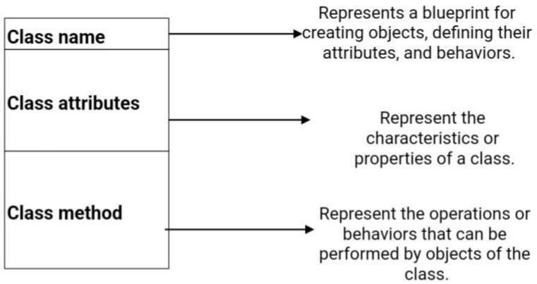

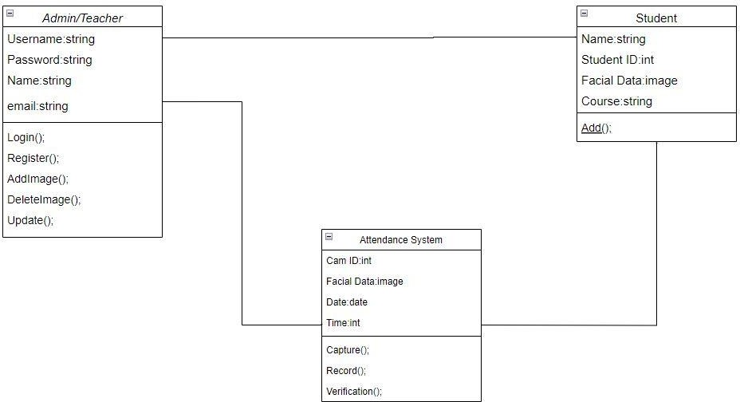

###### ER Diagram

An Entity-Relationship Diagram (ERD) is a visual representation of the data model for a system, showing the entities (objects), their attributes (properties), and the relationships between entities. For the “Attendance System ” project, the ERD will illustrate the main entities, their attributes, and the relationships between them. Here’s a simplified ERD for the project:

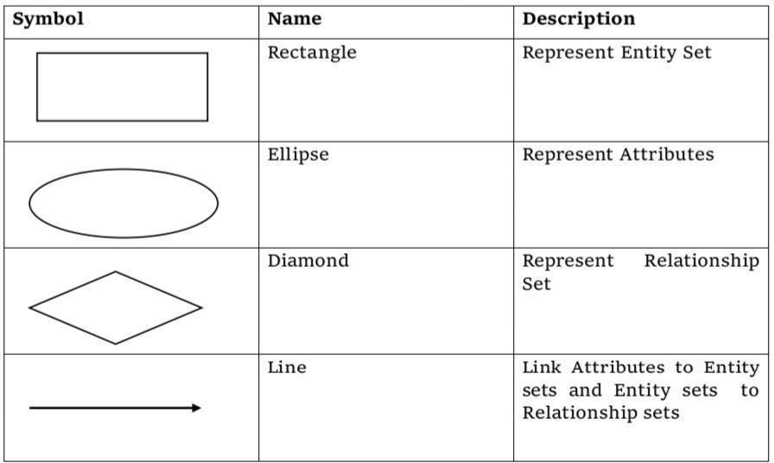

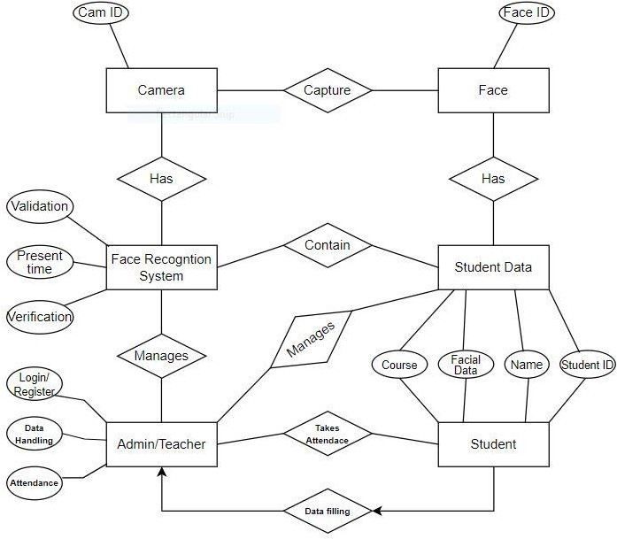

###### Use Case Diagram

A Use Case Diagram is a visual representation that illustrates the interactions between different actors (users or external systems) and the system under consideration. It helps to capture the functional requirements of the system showing the different ways in which users interact with the system and the corresponding actions performed. Here’s a simplified textual representation of the Use Case Diagram for the “Attendance System ” project:

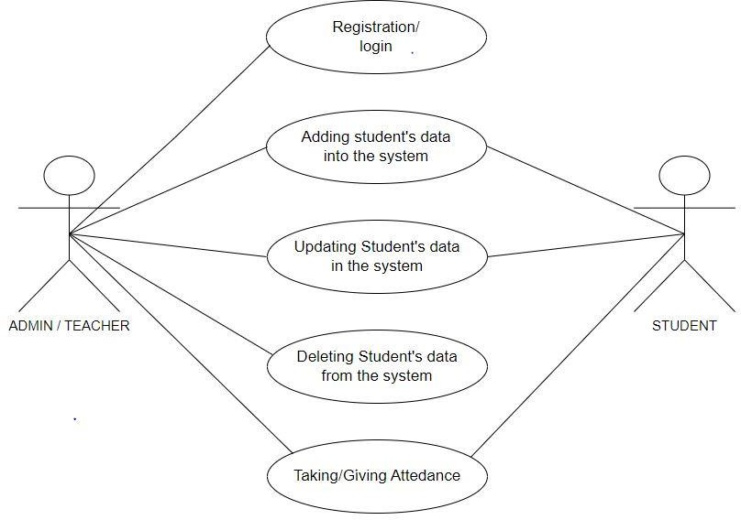

###### Data-flow diagram :-

A Data-flow diagram (DFD) is a way of representing a flow of a data of a process or a system. The DFD also provides information about the outputs and inputs of each entity and the process itself. A data-flow diagram has no control flow, there are no decision rules and no loops.

**Attendance System**

**Database**

**Admin/Teacher**

**Programmer**

###### Security Issues :-

In the System software the security is depend upon the login authentication of the admin . The admin password is knew to admin only no anyone can login to system . If a person tries to enter in software he needs to crack first these two Password. If he able to login then he can make changes or get details of someone.

* **Test Case Design:**-

|  |  |  |  |  |
| --- | --- | --- | --- | --- |
| Test  Case Id | Description | Steps/Action | Expected  Result | Pass/Fail |
| TC-01 | Verify Admin can access Attendance System | Login to the system , Then Click on Take  Attendance on Admin Page | The camera will open and start to  recognise faces | Pass |
| TC-02 | Verify Admin can store students face images | There is a folder named faces , Admin have to put students images in that  folder | Successful storing students images | Pass |
| TC-03 | Admin contacts Developer in case of any issues | There is a Contact Us button on Admin panel , Admin can contact developer  from there | Admin will message or email me about issue | Pass |

## IMPLEMENTATION AND TESTING

* Testing Approach :-

Software Testing is an investigation conducted to provide stakeholders with information about the quality of the product or service under test. It can also provide an objective, independent view of the software to allow the business to appreciate and understand the risk of software implementation. The basic purpose of testing is to detect the errors that may be present in the program. Testing as the process of executing a program with the intent of finding errors.

* The Box Approach :-

Software testing methods are traditionally divided into white-box and black-box testing. These two approaches are used to describe the point of view that a test engineer takes when designing test cases.

* White-box Testing :-

White box testing also known as clear testing, glass testing, and transparent box testing and structural testing. In white box testing an internal perspective of the system, as well as programming skills, are used to design test case. The testers choose inputs to exercisepaths through the code and determine the appropriate outputs. While whitebox testing can be applied at the unit, integration and system levels of the software testing process, it usually done at the unit level.

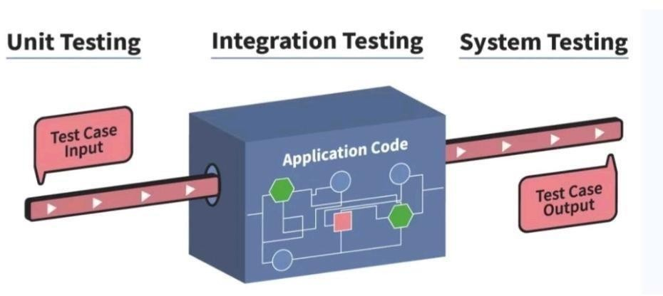

* Black-box Testing :-

Black box testing treats the software as a “black box”, examining functionally without any knowledge of internal implementation, without seeing the source code. The testers are only aware of what the software is supposed to do, not how it does it. Black box Testing methods include : equivalence portioning, boundary value analysis, all pairs testing state transition tables, decision table testing,

fuzz testing , model –based testing, use-case testing, exploratory testing and specification-based testing.

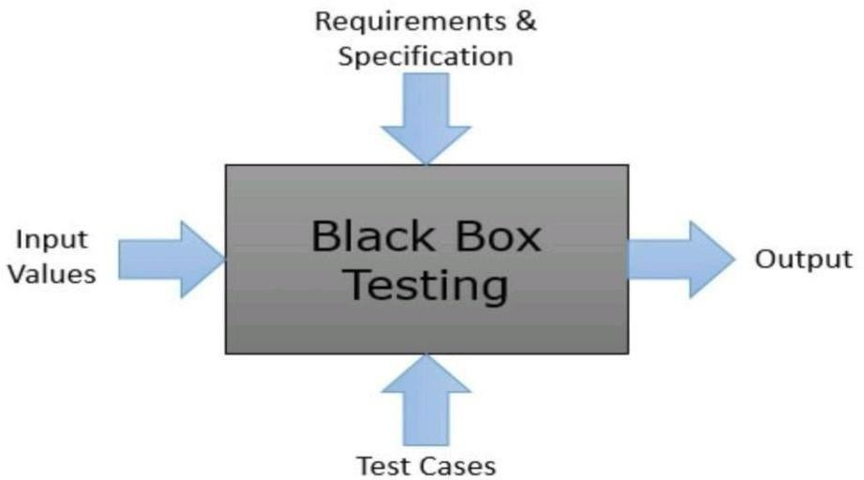

* Levels of Testing :

The levels of testing are as follows :

* 1. Unit Testing
  2. Integration Testing
  3. System Testing
  4. Acceptance Testing

1. Unit Testing :-

Unit testing focuses verification efforts on the smallest unit of the software design, the module. This is also known as “Module Design”. This testing carried out during programming stage itself. In this testing each module is found to be working satisfactorily as regard to the expected output from the module. All textboxes are having validation by which they will not remain empty and all work properly as expected. To store mobile number then the length must be 10 digits and only digit is allowed.

1. Integration Testing :-

Integration testing is systematic testing for construction the program structure while at the same time conducting tests to uncover errors associated with in the Interface. The objective is to take unit tested modules and build a program structure. All the modules are combined and tested as a whole. Here correction is difficult because the isolation of cause is complicated by the vast expense of the entire program. In Integration testing I test the system

combining all modules. All the customer data including his id, name, package that assign to member and total amount show together .

1. System Testing :-

It is the stage of implementation that is aimed at ensuring that the system works accurately and efficiently for live operation commences. Testing is vital to the success of the system. System testing makes a logical assumption that if all the parts of the system are correct, then goal will be successfully achieved.

1. Acceptance Testing:-

Acceptance Testing is a method of software testing where a system is tested for acceptability. The major aim of this test is to evaluate the compliance of the system with the business requirements and assess whether it is acceptable for delivery or not.

Coding Detail and code efficiency:-

In the software, to validate the form there are many if else and validation statements are used. The main or core part of software code is to perform database operation, sending mail, form validation. We are using SQL technology for database connection in C#.

All the fields such as Phone no, Email ID, Customer etc. are validated and does not take invalid values.

1. Avoiding errors in data.
2. Integration of all the modules/forms in the system.
3. Preparation of the test cases.
4. Preparation of the possible test data with all the validation checks.
5. Actual testing done manually.
6. Functionality of the entire module/forms.
7. Validations for user input.
8. Checking of the Coding standards to be maintained during coding.
9. Testing the module with all the possible test data.
10. Testing of the functionality involving all type of calculations etc.

##### Login Code :-

<?php

Session_start();

$isIndex = 1;

If(array_key_exists(‘teacher_id’,$_SESSION) && isset($_SESSION[‘teacher_id’])) {

Header(‘Location: teacher.php’);

} else {

If(!$isIndex) header(‘Location: index.php’);

}

?>

<!DOCTYPE html>

<html>

<head>

<link rel=”stylesheet” href=”css/style.css”/>

<title>Student Attendance</title>

<link rel=”stylesheet” href=”css/bootstrap.min.css”>

<link rel=”stylesheet” href=”css/bootstrap-theme.min.css”>

<script src=”js/jquery.min.js”></script>

<script src=”js/bootstrap.min.js”></script>

<script src=”js/login.js”></script>

<link href=”navbar-fixed-top.css” rel=”stylesheet”>

</head>

<body>

<nav class=”navbar navbar-inverse navbar-fixed-top”>

<div class=”container”>

<div class=”navbar-header”>

<button type=”button” class=”navbar-toggle collapsed” data-toggle=”collapse” data-target=”#navbar” aria-expanded=”false” aria-controls=”navbar”>

<span class=”sr-only”>Toggle navigation</span>

<span class=”icon-bar”></span>

<span class=”icon-bar”></span>

<span class=”icon-bar”></span>

</button>

<a class=”navbar-brand” href=”index.php”>Online Attendance</a>

</div>

</div>

</nav>

<div class=”container”>

<h2>For Students</h2>

<h4>Click here for <a href=”student.php”>Student Dashboard</a></h4>

<hr>

<h2>For Faculty</h2>

<div class=”alert alert-warning hidden”>

<span></span>

<button type=”button” class=”close” onclick=”$(‘.alert’).addClass(‘hidden’);”>&times;</button>

</div>

<table class=”table table-bordered table-striped”>

<thead>

<tr>

<th>Login</th>

<th>Sign Up</th>

</tr>

</thead>

<tbody>

<tr>

<td>

<form id=”login”>

<div class=”form-group”>

<label>Email ID</label>

<input class=”form-control” placeholder=”Email” type=”email” name=”email”>

</div>

<div class=”form-group”>

<label>Password</label>

<input class=”form-control” placeholder=”Password” type=”password” name=”password”>

</div>

<button class=”btn btn-primary pull-right”>Login</button>

</form>

</td>

<td>

<form id=”signup”>

<div class=”form-group”>

<label>Name</label>

<input class=”form-control” placeholder=”Name” type=”text” name=”name”>

</div>

<div class=”form-group”>

<label>Phone Number</label>

<input class=”form-control” placeholder=”Phone” type=”text” name=”phone”>

</div>

<div class=”form-group”>

<label>Email ID</label>

<input class=”form-control” placeholder=”Email” type=”email” name=”email”>

</div>

<div class=”form-group”>

<label>Password</label>

<input class=”form-control” placeholder=”Password” type=”password” name=”password”>

<span class=”help-block”>Password should be 6 characters long.</span>

</div>

<div class=”form-group”>

<label>Re-type Password</label>

<input class=”form-control” placeholder=”Re-type Password” type=”password” name=”password2”>

</div>

<button class=”btn btn-primary pull-right”>Sign Up</button>

</form>

</td>

</tr>

</tbody>

</table>

</div>

</div>

</body>

</html>

##### Dashboard code :-

<?php

Session_start();

$isIndex = 0;

If(!(array_key_exists(‘teacher_id’,$_SESSION) && isset($_SESSION[‘teacher_id’]))) {

Session_destroy();

If(!$isIndex) header(‘Location: index.php’);

}

?>

<?php include ‘php/node_class.php’; ?>

<html>

<head>

<link rel=”stylesheet” href=”css/style.css”/>

<title>Teacher Dashboard</title>

<link rel=”stylesheet” href=”css/bootstrap.min.css”>

<link rel=”stylesheet” href=”css/bootstrap-theme.min.css”>

<script src=”js/jquery.min.js”></script>

<script src=”js/bootstrap.min.js”></script>

<script src=”js/teacher.js”></script>

<link href=”navbar-fixed-top.css” rel=”stylesheet”>

</head>

<body>

<nav class=”navbar navbar-inverse navbar-fixed-top”>

<div class=”container”>

<div class=”navbar-header”>

<button type=”button” class=”navbar-toggle collapsed” data-toggle=”collapse” data-target=”#navbar” aria-expanded=”false” aria-controls=”navbar”>

<span class=”sr-only”>Toggle navigation</span>

<span class=”icon-bar”></span>

<span class=”icon-bar”></span>

<span class=”icon-bar”></span>

</button>

<a class=”navbar-brand” href=”index.php”>Online Attendance</a>

</div>

<div id=”navbar” class=”navbar-collapse collapse”>

<ul class=”nav navbar-nav navbar-right”>

<li class=”active”><a href=”teacher.php”>Dashboard</a></li>

<li><a href=”profile.php”>Profile</a></li>

<li><a href=”statistics.php”>Statistics</a></li>

<li><a href=”logout.php”>Logout</a></li>

</ul>

</div>

</div>

</nav></br></br></br></br>

<div class=”container”>

<?php

$name = $_SESSION[‘name’];

$classes = $_SESSION[‘classes’];

$teacher_id = $_SESSION[‘teacher_id’];

Echo ‘<h2>Welcome , ‘.$name.’.</h2>’;

Echo ‘<div class=”wrapper”>’;

$n = new Node;

If(!$classes) {

Echo ‘<h3 class=”no-classes”>You haven\’t taken any class yet!</h3>’;

} else {

Echo ‘<h3 class=”no-classes”>Click on a class to take attendance.</h3>’;

Foreach($classes as $class_id) {

$node = $n->retrieveObjecti($class_id,$teacher_id) or die(“No such record”);

$code = $node->getCode();

$section = $node->getSection();

$year = $node->getYear();

$numClasses = $node->getDays();

$link = ‘take.php?cN=’.$class_id;

Echo ‘<div class=”class”>

<button class=”btn btn-danger delete-class-warning” data-toggle=”modal” data-target=”.delete-warning”>&times;</button>

<a class=”no-decoration” href=”’.$link.’”>

<div><strong>Code</strong> : <span class=”code”>’.$code.’</span></div>

<div><strong>Section</strong> : <span class=”section”>’.$section.’</span></div>

<div><strong>Year</strong> : <span class=”year”>’.$year.’</span></div>

<div><strong>Classes</strong> : ‘.$numClasses.’</div>

</div></a>’;

}

}

Echo ‘<div class=”class” data-toggle=”modal” data-target=”.bs-example-modal-lg” id=”addClass”>

<span class=”glyphicon glyphicon-plus”></span>

</div>

</div>’;

?>

</div>

<div class=”modal fade bs-example-modal-lg” tabindex=”-1” role=”dialog” aria-labelledby=”addClass” aria-hidden=”true”>

<div class=”modal-dialog modal-lg”>

<div class=”modal-content”>

<h2 class=”text-center”> Add Class </h2>

<hr>

<div id=”add_class_form”>

<select class=”form-control” name=”year”>

<?php foreach(range(date(‘Y’,time()),1983) as $r) echo ‘<option>’.$r.’</option>’; ?>

</select>

<input class=”form-control” name=”code” placeholder=”Code , Eg : COE-322”>

<select class=”form-control” name=”section”>

<option value=”-1”>Choose Batch</option>

<?php foreach(range(1,3) as $r) echo ‘<option>’.$r.’</option>’; ?>

</select>

<select class=”form-control” name=”semester”>

<option value=”-1”>Choose Semester</option>

<?php foreach(range(1,6) as $r) echo ‘<option>’.$r.’</option>’; ?>

</select>

<input class=”form-control” name=”start” placeholder=”Starting Roll Number (Eg. 201/CO/12)”>

<input class=”form-control” name=”end” placeholder=”Ending Roll Number (Eg. 265/CO/12)”>

<button class=”btn btn-primary” id=”add”>Add Class</button>

<button class=”btn” id=”cancel”>Cancel</button>

</div>

</div>

</div>

</div>

<div class=”modal fade delete-warning” tabindex=”-1” role=”dialog” aria-labelledby=”delete-warning” aria-hidden=”true”>

<div class=”modal-dialog modal-sm”>

<div class=”modal-content”>

<h2 class=”text-center”> Do you really want to delete <br> <span class=”warning-class”></span> ?</h2>

<hr>

<div class=”text-center”>

<p>

Are you sure you want to delete <span class=”warning-class”></span> ? <br>

You can’t undo this action.

</p>

<button class=”btn btn-danger delete-class-code”>Delete</button> <button class=”btn btn-primary” onclick=”$(‘.delete-warning’).modal(‘hide’);”>Cancel</button>

</div>

</div>

</div>

</div>

</body>

</html>

# Results

#### Signup/Login Page :-

#### 

#### Validation :-

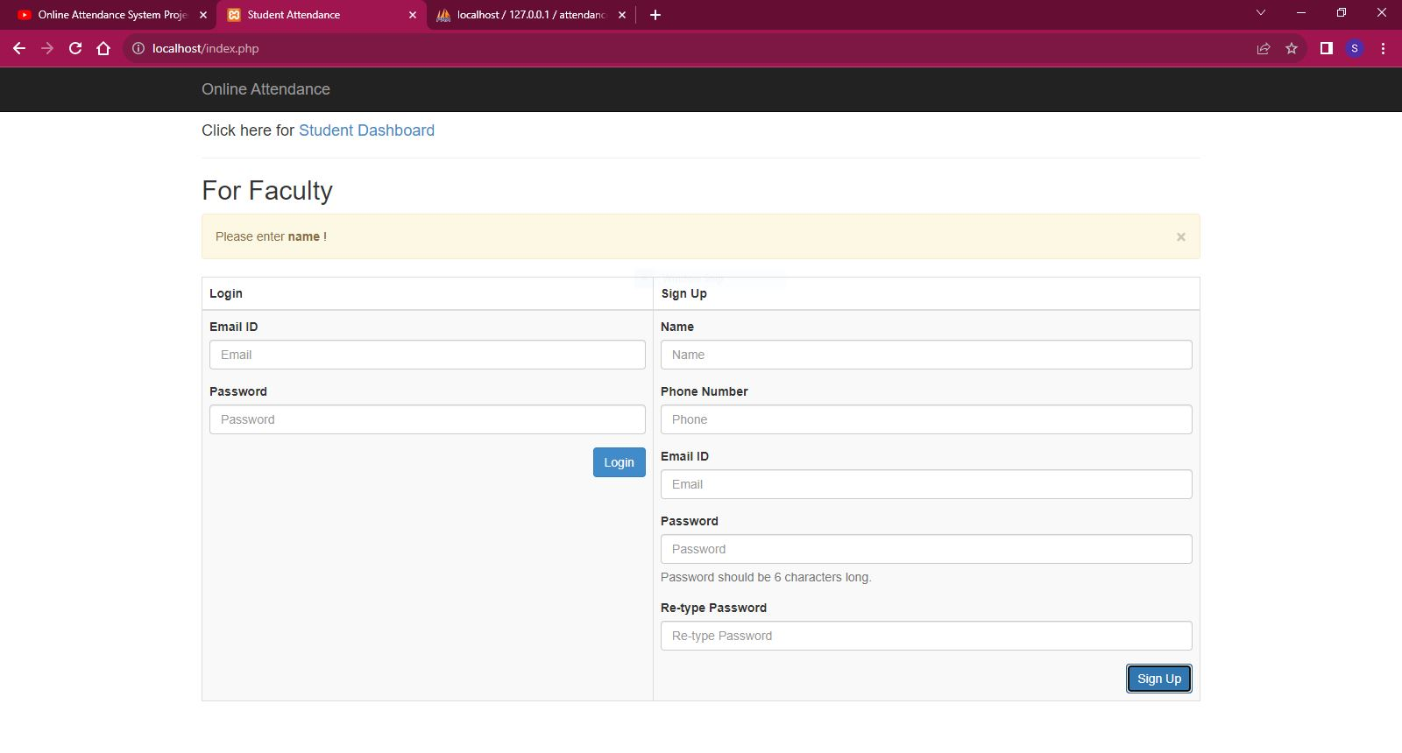

#### Dashboard :-

#### 

#### Profile :-

**SYSTEM MAINTANENCE**

**Advantages over Current System :-**

In the Existing system the work are done only manually but in proposed system we can do our with computerized system using this application. Existing system includes following points:-

* Lack of security of data.
* More man power.
* Time consuming.
* Consumes large volume of pare work.
* Needs manual calculations.
* No direct role for the higher officials

The aim of proposed system is to develop a system of improved facilities. The proposed system can overcome all the limitations of the existing system. The system provides proper security and reduces the manual work.

* Security of data.
* Ensure data accuracy’s.
* Proper control of the higher officials.
* Minimize manual data entry.
* Minimum time needed for the various processing.
* Greater efficiency.
* Better service.
* User friendliness and interactive.
* Minimum time required.

**At the end it is concluded that we have made effort on following points…**

* A description of the background and context of the project and its relation to work already done in the area.
* The description of Purpose, Scope, and applicability.
* We define the problem on which we are working in the project.
* We describe the requirement Specifications of the system and the actions that can be done on these things.
* We understand the problem domain and produce a model of the system, which Describes operations that can be performed on the system.
* Finally, the system is implemented and tested according to test cases.

**Future Enhancement:-**

**It can be summarized that the future scope of the project circles around maintaining information regarding**:

* + We can add webcam in future.
  + We can give more advance software for Attendance System including more facilities
  + We will host the platform on online servers to make it accessible worldwide
  + Integrate multiple load balancers to distribute the loads of the system
  + Create the master and slave database structure to reduce the overload of the
  + Database queries Implement the backup mechanism for taking backup of codebase and database on regular basis on different servers
  + The above mentioned points are the enhancements which can be done to increase the applicability and usage of this project.
  + Here we can maintain the records of Students . So there is a scope for introducing a method to maintain the Attendance System .

**Conclusion:-**

* An attempt is made in all its earnest towords the successful completion of the project the system is verified with valid as well as invalid data.
* The system is user friendly since it has been developed in visual studio code a successful GUI environment. since the connections can be extended to any database The control will be more powerful.
* Upgrading the system if may can be done without affecting the current proper functioning of the system.

Although I have put my best efforts to make the software flexible, easy to operate but limitations cannot be ruled out even by me.

**System Maintenance :-**

System maintenance is crucial to ensure continued effectiveness and reliability of the Application:

**Regular Updates:** Ongoing updates to the application's components (HTML, CSS, JavaScript, PHP, MySQL) are essential to address security vulnerabilities, improve performance, and add new features. Regularly applying patches and updates keeps the system secure and up-to-date.

**Data Backup:** Scheduled data backups of the MySQL database should be conducted to prevent data loss due to unexpected issues such as hardware failures or data corruption.

**Performance Monitoring:** Constantly monitoring system performance helps identify and resolve bottlenecks, slow response times, or resource issues. This proactive approach ensures the system runs smoothly and provides a positive user experience.

**User Support and Training:** Providing ongoing user support and training for both administrators and end-users is vital. This helps users navigate the system effectively, troubleshoot common issues, and maximize the application's benefits while reducing user frustration.

#### References

While developing this project internet was the eternal support. Following are the websites referred by us which helped us in developing our projects

* + Wikipedia
  + Google (application) for problem solving
  + YouTube (application)